Pako Raseleka

ST10131302

PROG6221

POE

Recipe App User Manual

Introduction:

The Recipe App is designed to provide users with the ability to add and search for existing recipes. We have placed a user interface to allow the app to be more appalling to common user. This user manual will guide you through the key features and functionalities of the app.

We plan to make our application to have over 1000+ recipes and meals for all our users

Open the Application

as you open the application, they should be title called “Recipe Names” you should place the name of the meal/Recipe you want to make.

AS you use the application there will be steps you will need to follow

Such as

Enter Recipe

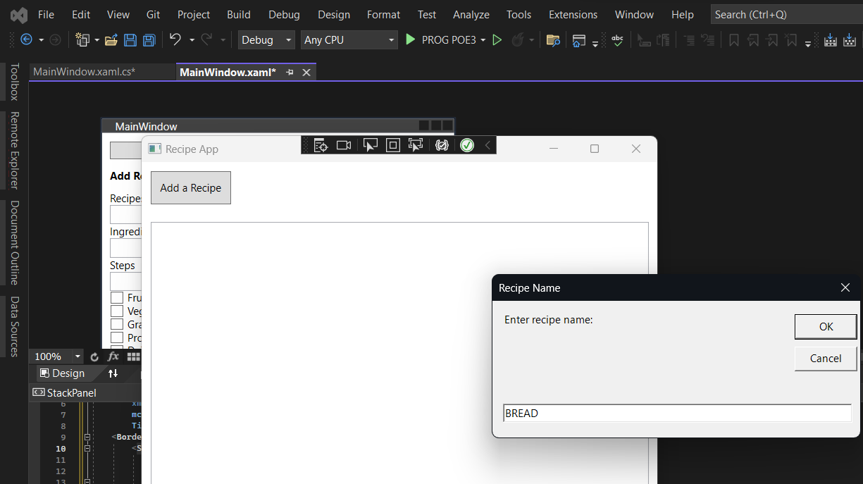

Enter the Number of ingredients.

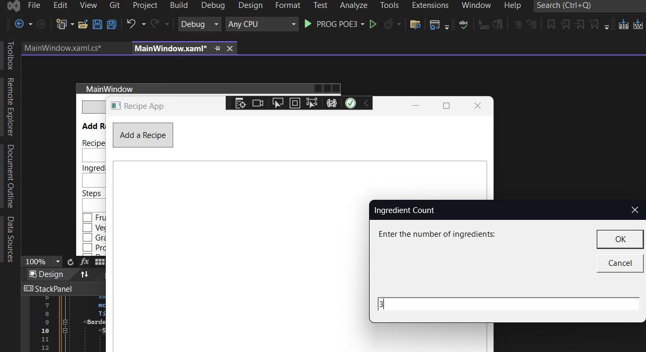

ENTER THE QUANTITY

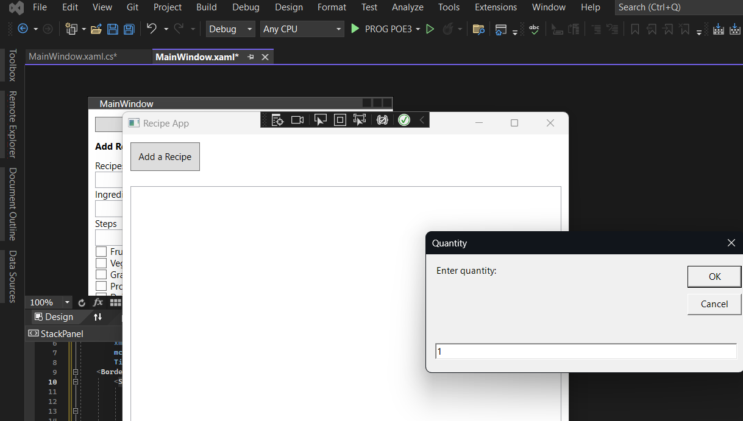

ENTER THE UNIT OF MEASUREMENT

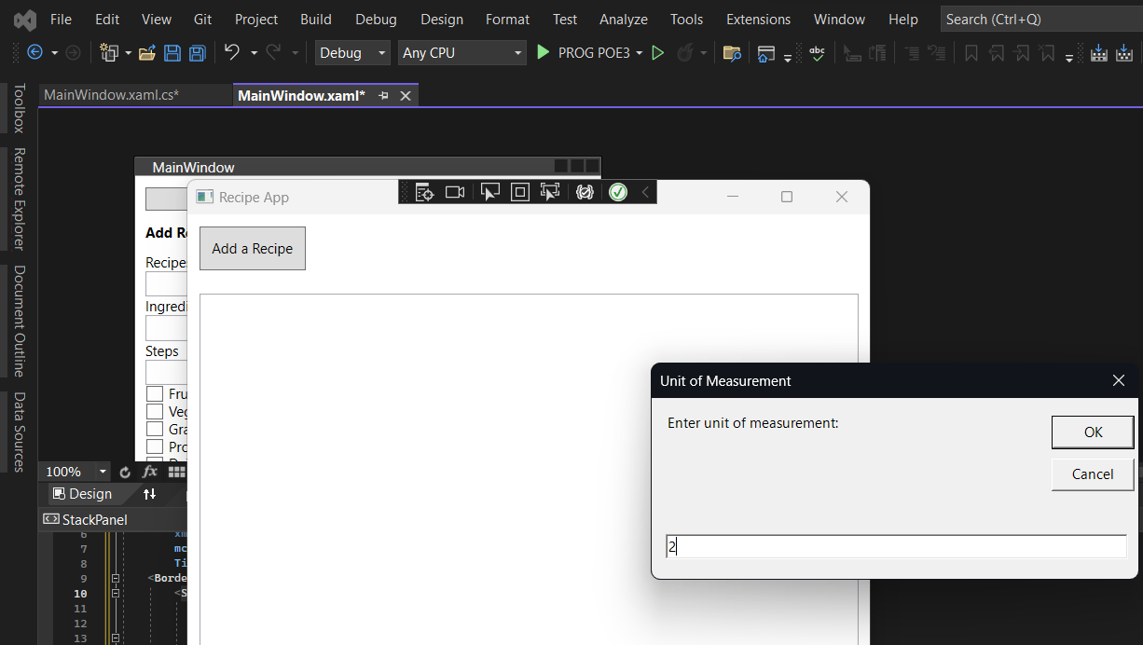

ENTER THE AMOUNT OF CALORIES

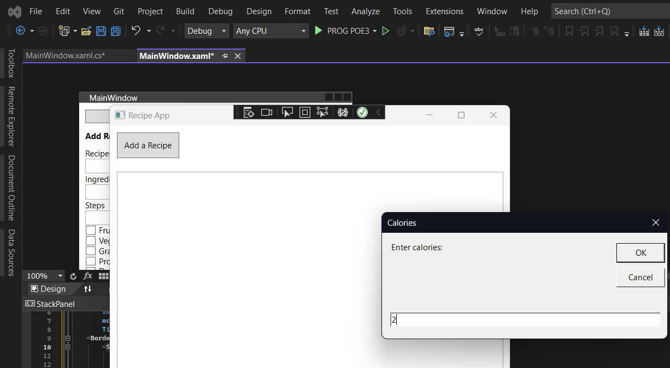

ENTER THE FOOD GROUP OF THE INGREDIENTS

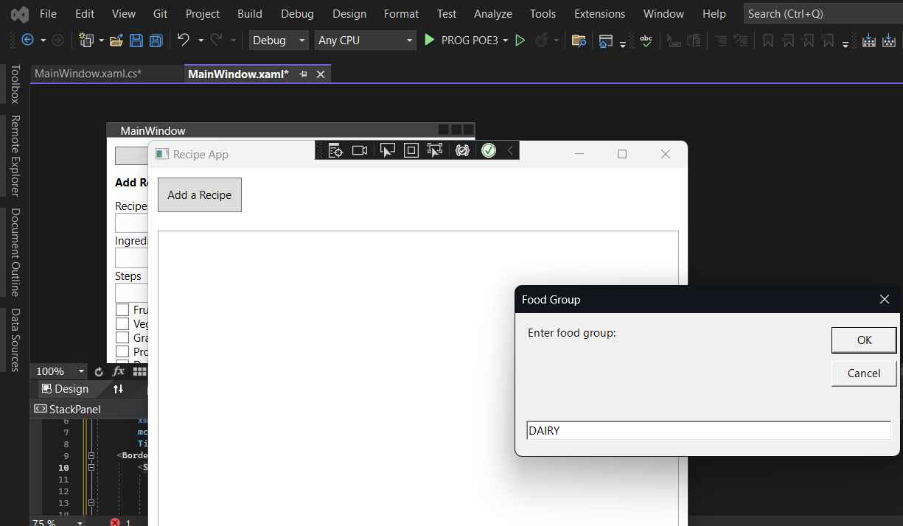

At the end of the process, you will see your recipe on display and as you click it you will see all the steps you have to take to make your meal.

The search bar added to our application can work located keywords of other ingredients and food groups to your liking as we plan to add a database that has a link to the internet .